Program 1

1. Problem Definition: Write a program to download a textfile from online. Preferably something interesting. Then reopen and read the file and display the output in a well formatted way.
2. Problem Analysis: Take website and create a text file that saves information for ever 10000 bytes. The reopen the file in read mode.
3. Program Algorithm:

* Take website and Request it
* Open\create a blank file
* Use iter_content to upload 10000 bits at a time
* Write those bits in a text file
* Display the information in nice formatting

1. Program Code and Test:

# Author == 'Darren Isaacson'

# This program is designed to download a text file.

import requests

def main():

fileDownload()

fileRead()

def fileDownload():

file = requests.get('https://sherlock-holm.es/stories/plain-text/advs.txt') # Gathers text website address

openFile = open('THE ADVENTURES OF SHERLOCK HOLMES.txt', 'wb') # Creates a text file that writes.

for words in file.iter_content(10000): # For every 10000 bytes it sends

openFile.write(words) # Where it is actually being written

openFile.close()

def fileRead():

fileData = [] # create an array

readFile = open('THE ADVENTURES OF SHERLOCK HOLMES.txt', 'r', newline='') # open in read ‘r’ mode

myData = (readFile.readline()) # read a line

while myData: # loop while there is something to read

fileData.append(myData) # append a file line to the array

myData = (readFile.readline()) # read the next line

for line in fileData: # loop through the array

if line != '':

print(line)

else: # If there is nothing else in the file

break

main()

Output:



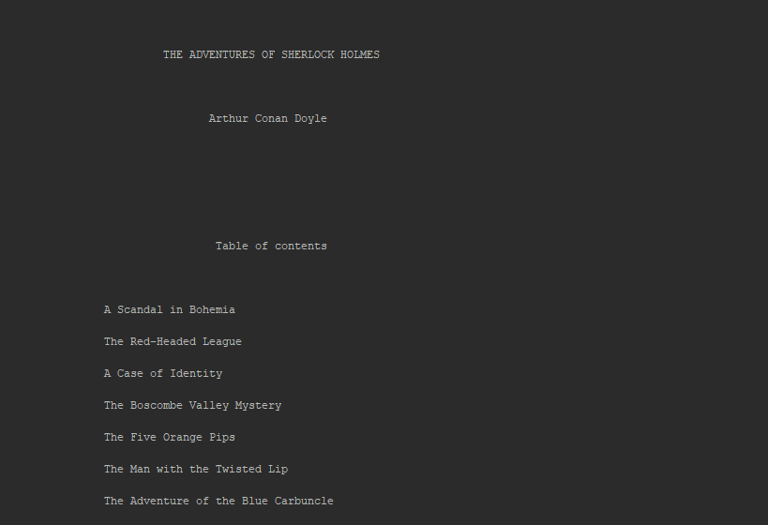

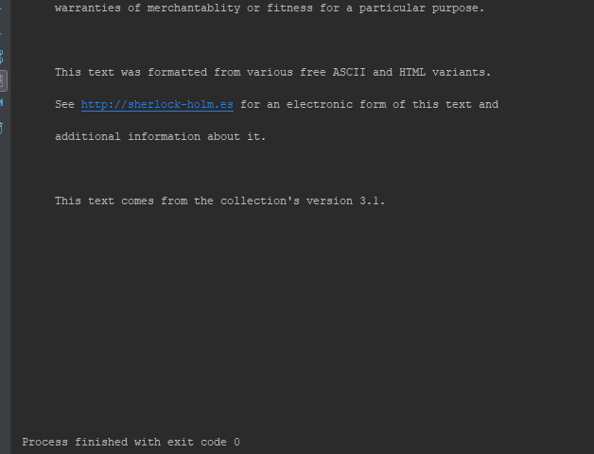

Program 2

Problem Definition Write a program to accept input from the user and create a csv file with name, email address, and phone number for 6 people. The program should then display the csv data in a nice looking table with appropriate column headings.

Problem Analysis: Make a function that collects input and converts it into a list. List get put into a bigger list and converted into a csv file. The file is then put through a for loop for output.

Program Algorithm:

* Make a while loop that Create 3 inputs that collect the name, email, and phone numbers.
* The loop will restart if the user just presses enter.
* That information is put into a small list.
* The information for the small list is then put into the motherlist that houses all of the smaller lists.
* Then the motherlist is converted and written into a csv file called list.csv.
* Then the csv file is opened in a table.
* Display the name, email, and phone using nice formatting.

Program Code and Test:

# Author = "Darren Isaacson"

# This program is designed to create a csv file.

import csv

def main():

list = getInput() # Get user input

csvConverter(list) # Convert list into csv file

csvTable() # create a basic table.

def getInput():

print("This is a contact creator program. It can list the name, email, and phone number that you would like to add.")

print('-------------------------------------------------------------------')

dataList = [['Name', 'Email', 'Phone'], ['-------', '-------', '-------']]

while True:

# While loop so that the user can add as many inputs as they wish

personList = [] # Blank List for adding in.

name = input("Enter in a name:") # Gets name

personList.append(name) # adds to blank list

email = input("Enter in a email:") # Gets email

personList.append(email)

phone = int(input("Enter in a phone number")) # Gets Phone

personList.append(phone)

dataList.append(personList) # Concatenates list together

another = input("Would you like to enter another? Press enter to add in another contact. Otherwise press any other key to stop") # This the continue statement

if another == "":

print("-------------------------------------------------------------------------")

else:

break

return dataList

def csvConverter(list):

outputFile = open('List.csv', 'w',newline='') # Opens and writes a new file

for row in range(len(list)): # Iterates each value

outputWriter = csv.writer(outputFile) # This writes in csv format

outputWriter.writerow(list[row]) # This appends to the list.csv file

outputFile.close()

def csvTable():

table = open("List.csv") # Opens the file

csv_table = csv.reader(table) # Puts it in view mode

for row in csv_table: # Row = for every right. Think of it as a row and column from excel.

print('{:<15} {:<30} {:<15} '.format(*row)) # {:15} is a spacing holder.

main()

Output



